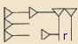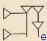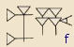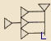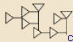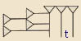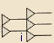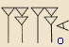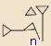
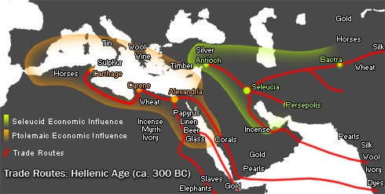
Babylon was one of the world’s first ancient civilizations. Founded in 2350 B.C., in the region known as Mesopotamia, it was a popular hotspot. Located between the two rivers, Tigris and Euphrates, it was the center of trade for Mesopotamia. Babylon had many great firsts, including the Code of Hammurabi; the world’s first set of laws. These laws paved the way for future laws to come. Subsequently, Babylon was the monumental city of ancient civilizations.

Trade routes

