Tyler Bredlow
Period 2 Honors History
Babylonia was a flourishing empire, and at its center, was Babylon. Founded in 2350 BC, it was one of the first ancient civilizations. All the way up until it’s downfall in 312 BC, it was a major trading hub. It was the New York City of Mesopotamia. During this period of time, it was ruled by at least nine different empires.
Babylon
2350 – 312 B.C.

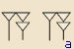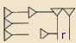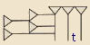
Most art was either mosaic or chiseled in stone.
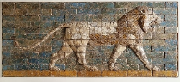
If the entire picture was here, it would show two lions roaring at each other
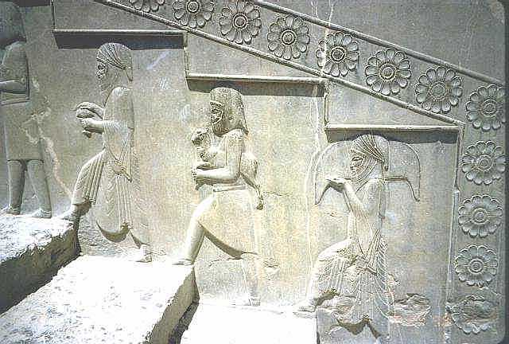
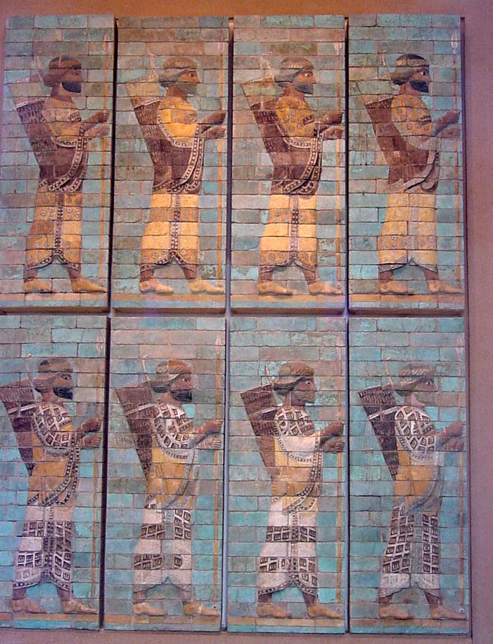
Chiseled stone showing men walking up the stairs
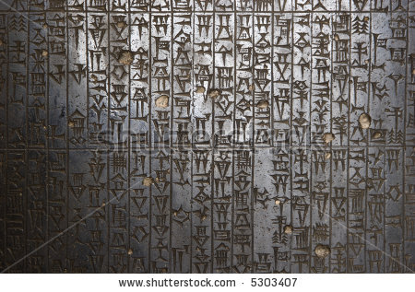

A brief look at some Cuneiform

Again, a mosaic, depicting rows of soldiers

A cylinder seal
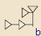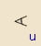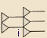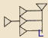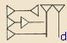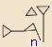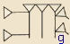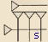
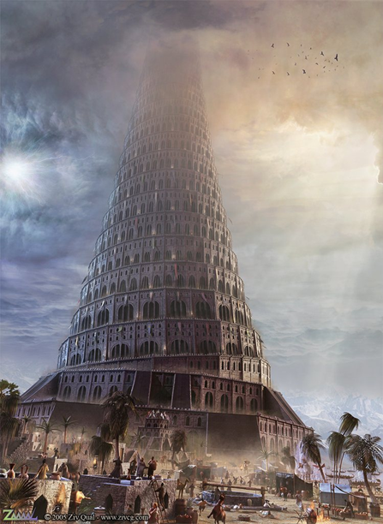
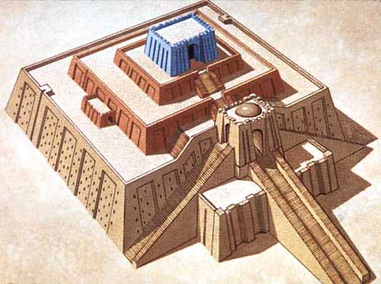
A look at some monumental buildings

Ziggurat. Used as a religious temple and gathering place
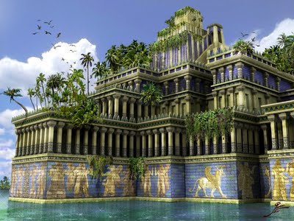

Tower of Babel. Was never completed
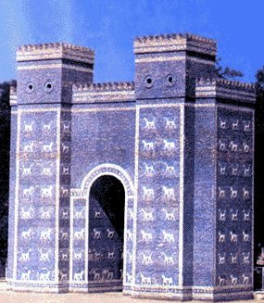

Hanging Gardens of Babylon. One of the Seven Wonders of the World
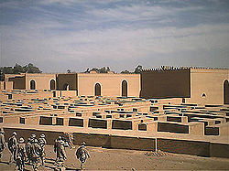

Entrance to a temple
Some rebuilt ruins

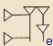
A glimpse back in time as we look at some important rulers
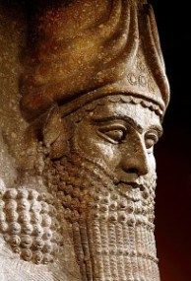
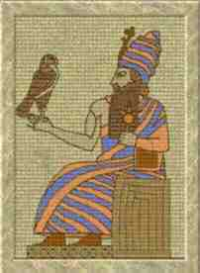

King Hammurabi Nebuchadnezzar II
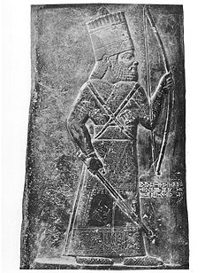
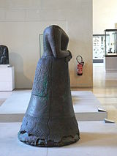

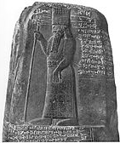
Napir-asu

Marduk-nadin-ahhe

Nabu-Mukin-Apli
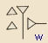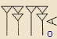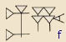
Some of Babylon’s inventions
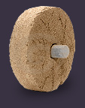
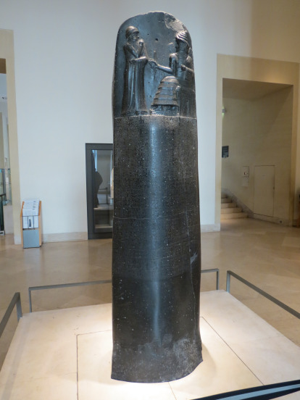

The wheel. Wasn’t used for transportation until 300 years after it was invented
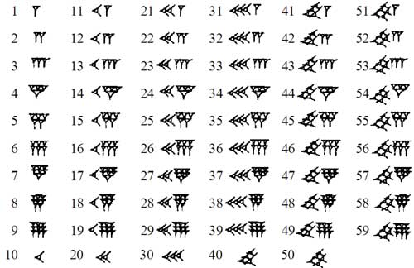
Code of Hammurabi. World’s FIRST set of laws.

A cylinder seal
Cuneiform (these are numbers)

They had many inventions in the field of astronomy

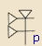
Weapons of mass destruction…..sort of
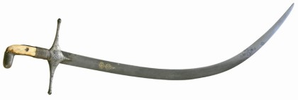
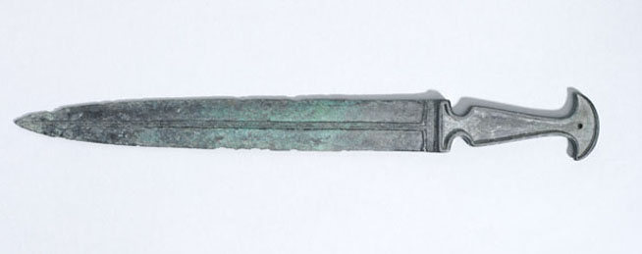

Sword of Babylonian King Marduk-shapik-zeri A bronze dirk
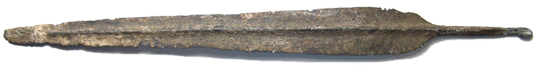
A bronze spearhead
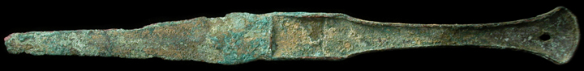
A bronze dagger
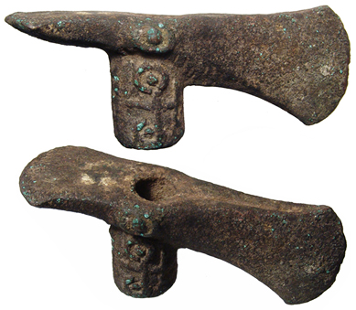

A bronze axe head

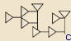
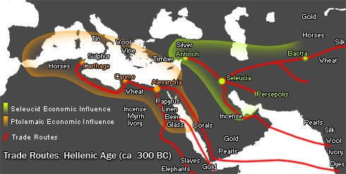
Babylon was one of the world’s first ancient civilizations. Founded in 2350 B.C., in the region known as Mesopotamia, it was a popular hotspot. Located between the two rivers, Tigris and Euphrates, it was the center of trade for Mesopotamia. Babylon had many great firsts, including the Code of Hammurabi; the world’s first set of laws. These laws paved the way for future laws to come. Subsequently, Babylon was the monumental city of ancient civilizations.

Trade routes

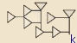
"About Facts Net." About Facts Net. About Facts, n.d. Web. 27 Mar. 2014.
"Aktuelles." M.Khorasani Consulting. N.p., n.d. Web. 28 Mar. 2014.
"Ancient Computers." - GHN: IEEE Global History Network. N.p., n.d. Web. 27 Mar. 2014.
"Ancient Resource: Ancient Persian Weapons for Sale." Ancient Resource: Ancient Persian Weapons for Sale. N.p., n.d. Web. 28 Mar. 2014.
"Astronomy." Wikipedia. Wikimedia Foundation, 04 Jan. 2014. Web. 28 Mar. 2014.
"Babylon." Wikipedia. Wikimedia Foundation, 04 Feb. 2014. Web. 27 Mar. 2014.
"Detail from the Code of Hammurabi Stela. Babylonian Laws (circa 1760 BC)." Detail From The Code Of Hammurabi Stela. Babylonian Laws (Circa 1760 Bc) Stock Photo 5303407 : Shutterstock. N.p., n.d. Web. 27 Mar. 2014.
Duyer, James M. "Cuneiform Translation." Http://www.paleoaliens.com/. James Duyer, n.d. Web. 27 Mar. 2014.
"IL RITORNO DI HAMMURABI | Noicittadinilucani | Il Cannocchiale Blog." IL RITORNO DI HAMMURABI | Noicittadinilucani | Il Cannocchiale Blog. N.p., n.d. Web. 28 Mar. 2014.
"Marduk-nadin-ahhe." Wikipedia. Wikimedia Foundation, 30 Mar. 2014. Web. 27 Mar. 2014.
"Nabu-mukin-apli." Wikipedia. Wikimedia Foundation, 22 Mar. 2014. Web. 28 Mar. 2014.
"Nebuchadnezzar's Tower of Babel ? (Great Empires)." If It Happened Yesterday Its History. N.p., n.d. Web. 27 Mar. 2014.
"Parablesblog: Babylon Rising - Part Three: The XXX Olympiad." Parablesblog: Babylon Rising - Part Three: The XXX Olympiad. N.p., n.d. Web. 27 Mar. 2014.
"Paris Sights Previously Unseen: The Louvre and the Dali Museum." La Vie De Kelsey. N.p., n.d. Web. 28 Mar. 2014.
"Unfulfilled Expectations." : Gardening with Babylon. N.p., n.d. Web. 27 Mar. 2014.
"Weapon Wednesday." Www.rom.on.ca. Royal Ontario Museum, n.d. Web. 28 Mar. 2014.
"West Asian Art." Persian Art. Kidepide, n.d. Web. 27 Mar. 2014.
Wikipedia. Wikimedia Foundation, n.d. Web. 27 Mar. 2014.
"Ziggurats - Crystalinks." Ziggurats - Crystalinks. N.p., n.d. Web. 27 Mar. 2014.
"ZIVCG.COM - Portfolio." ZIVCG.COM - Portfolio. ZIVCG.COM, n.d. Web. 27 Mar. 2014.

